**School of Electrical**

**and Electronic Engineering**



**Robot Orchestra**

**Final Report**

**Group 11**

|  |  |  |
| --- | --- | --- |
| Group Members: | Buruiana, Andrei | 9478411 |
|  | Chanda, Joyanto | 9015629 |
|  | Dimou, Theodoros | 9126435 |
|  | Fumagalli, Francesco | 9017237 |
|  | Petrovs, Antons | 9474345 |
|  | Simpson, Joshua | 8929879 |

Tutors: Prof. Danielle George and Dr. William McGenn

Date: 15 May 2018

Table of Contents

1. Heading 1 3

1.1. Heading 2 3

1.1.1. Heading 3 3

1.1.2. Bullet points 3

2. References 4

# Tesla Coil

It was decided to make a tesla coil as it demonstrates the power sie fo electrical engineering and can provide the orecestra with better visuals.

To start tesla coil circuits were investigated and it was found small tesla coil kits could be bought from amazon. Three tesla coil kits were bought to test.

The circuit for the tesla coil kits was provided with the kits but the description was in Chinese as can be seen from Appendi. Therefore, to progress with the tesla coil the kits were tested to figure out how the circuit works. Circuit diagram below.



The circuit works as a high frequency oscillator where Q1 and Q2 switch on and off which creates an approximate sinusoidal waveform (figure) over the primary coil causing a voltage to be induced in the secondary which produces sparks/corona discharge at the open end of the secondary coil. When a music waveform is applied at V1 it modulates the power supply to the coil causing the switching waveform to be amplitude modulated.

Single oscillation over the primary coil

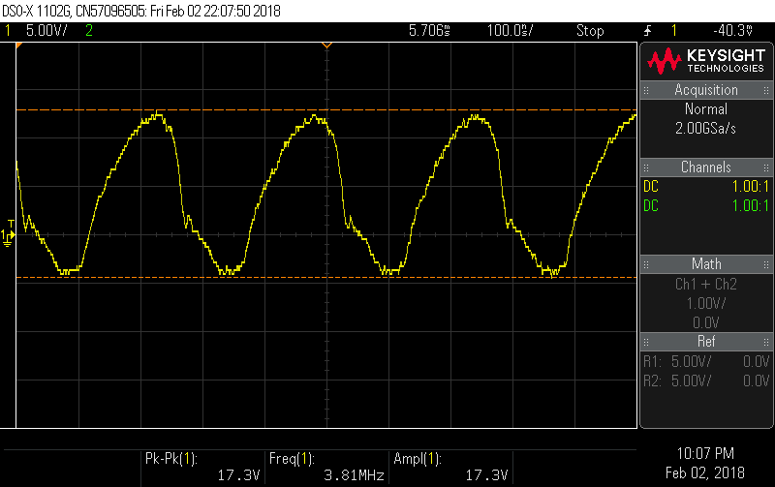As it can be seen the switching frequency is about 1/250n=4Mhz. as the turns ratio is 350 there will be a voltage ranging from +13 to -4V over the primary and 4550 to-1400V

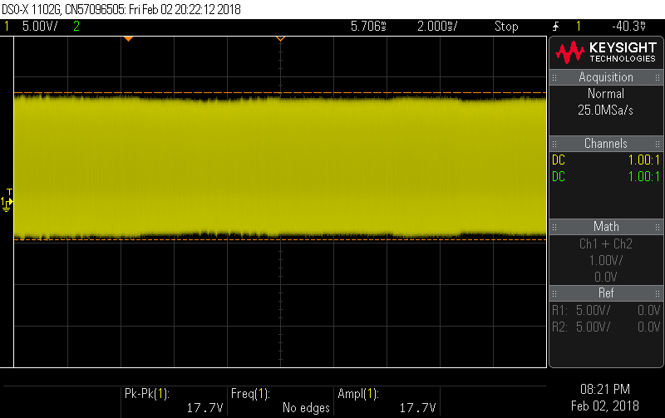Voltage wavform over the primary coil with no music playing

Voltage wavform over the primary coil with ‘eye of the tiger’ playing

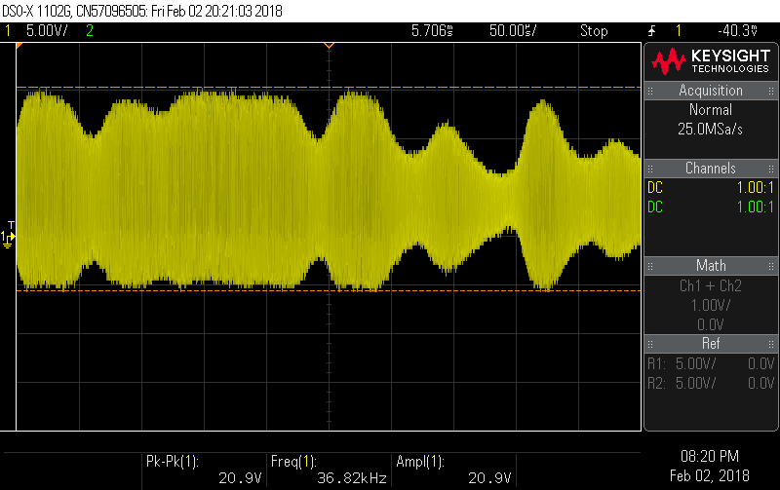The frequency of the audio wave form is about 1/75us=13khz this is as expected as it is in the audible frequency range.

Issues found while testing.

After continued use the sound produced by the tesla coil reduces in volume and the sparks become smaller. This is suspected to be due to the BJT heating up and so the losses increasing. The amazon description does warn about using the tesal coil for more than 3 minutes. Reducing the current that flows in the bjt from C to E which will reduce the field produced by the tesla coil and thefore the voltage induced in the secondary.

The coil is also sensitive to the primary coil position as the primary coil can move as there is nothing supporting it. As it moves further down the coil it stops the flux linkage linking the secondary coil this can be mitigated by inserting a ferrite coil into the secondary coil.

The limitation of the tesla coils is that they are currently not that loud. Using phone app it come in around … dB this is about the same as a… as can be seen in figure 3 the amplitude of the sound is controlled by the voltage amplitude. Therefore to increase the volume the voltage need to be increased this can be done by increasing the number of turns in the secondary coil or increasing the input voltage. increasing the input voltage has the limitation that it cannot exceed the amplitude of the power supply the components are rated for a 24V supply but this would only increase by a factor of 30%.

Currently the sparks produced by the tesla coil are 2mm long as the breakdown of air is 3kV/mm. if the number of turns was increased to 10000 from 350 it woul increase the length of the streamers to 10000*20/3000=67mm=6.7cm. This would in theory increase the sound to 10000/350=28.6 time the original increasing the volume to …. Db. If this was done the switching circuit for the tesla coil on it would be at risk of being damage by the streamers as they would reach the PCB. So remove this problem the PCB would have to be split so the switching circuit can be removed from the vicinity. A rod would also probably need to be provided to catch the streamers. The secondary coil would have to be placed in a faraday cage so nobody can touch the coil and get injured.

The testing of the new coil would have to take place in the high voltage lab discussion wer had with the operators howerver due to inprovment works and demands on the remaining test spaces the team was unable to get acess for testing in the time available.

The solution decided on was to use a microphone to pick up the sound this used a amplifer circuit already designed for the xylophone to amplify the microphone output to connect it to a speaker. As the spark is to remain small a webcam is going to be used to display the tesla spark on a screen. The tesla coil will be housed in ab box so it cannot be touch by observers so it can be used safely as part of the orchestra. The health and safety for the coil is in the appendix.

To deal with the heat problem a new PCB is to be designed with new heatsink and components. It was also designed so a teensy and DSS could be connected to control it. The design is shown below. The coils were also put on a separate PCB to make testing and transportation easier and make it easier to expand in the future.

Two new PCB’s ned to be made the components chosen for this are specified below (insert table+specs)

BJT

MOSFET

Capasitors

Other

Heat sink calculations.

Coil of wire spec

During testing several issues were found with the PCB. Several errors were found on the PCB there was a connection missing to the collector of the BJT (Q1). It was also found that the circuit provided in the tesla kits was not the same as the PCB layout on the test kits. This mean that a LED had to have its position changed. It was also found that the new BJT specified didn’t work properly with the circuit as it didn’t start to oscillate with the MOSFET so the original transistor was tried and it worked. These errors were fixed and a new PCB was printed as the testing was proceeding an alternative method was explored to use the original kit PCB with adjustments to use larger heat sinks and to be used with the Teensy. So if the new PCB still had faults when reprinted this would be mitigated the risk. There was also a power circuit made so the tesla can be turned off in between songs to limit the amount of heat the heatsinks have to deal with. This includes a manual switch and a pnp transistor that can be turned on and off by the microcontroller.

The micro controller works in the same way as the stepper with a few changes such as different tracks to be played a switch to turn off the tesla between uses.

# References

[1] BBC, “BBC Radio 1 - Can a robot replace Ed Sheeran?,” BBC, 3 March 2017. [Online]. Available: <http://www.bbc.co.uk/programmes/p04sxvgw> [Accessed October 2017].

[2] L. Mather, “Glock o Bot,” YouTube, 13 June 2016. [Online]. Available: <https://www.youtube.com/watch?v=4toW8Tc9GPI> [Accessed October 2017].

[3] National Instruments, “Student Project Sponsorship - National Instruments United Kingdom,” National Instruments, 12 August 2017. [Online]. Available: <http://uk.ni.com/studentsponsorship> [Accessed November 2017].

[4] The editors of Encyclopedia Britannica. (2012). *Idiophone*. [Online] Available at: <https://www.britannica.com/art/idiophone> [Accessed November 2017].